

**SPORTS NOW!**

iOS/Web Application

Up to date news and how-to tips for all you new sports fans. Just a simple website to explain everything you need to know about mainstream sports.



We like to offer the best tips and sports news to our users and fans here on SPORTS NOW! We like to give out tips to anyone who wants to learn basketball, football, and baseball. We also give out the latest professional college and professional news to all users on the web whether on the go on your smartphone or on your computer at home. We provide quick easy tips to show how a sport is played or just tips on techniques with certain moves.

**Personas**



Gary the Sports Enthusiast

Jennifer the Teacher

Norman the Beginner

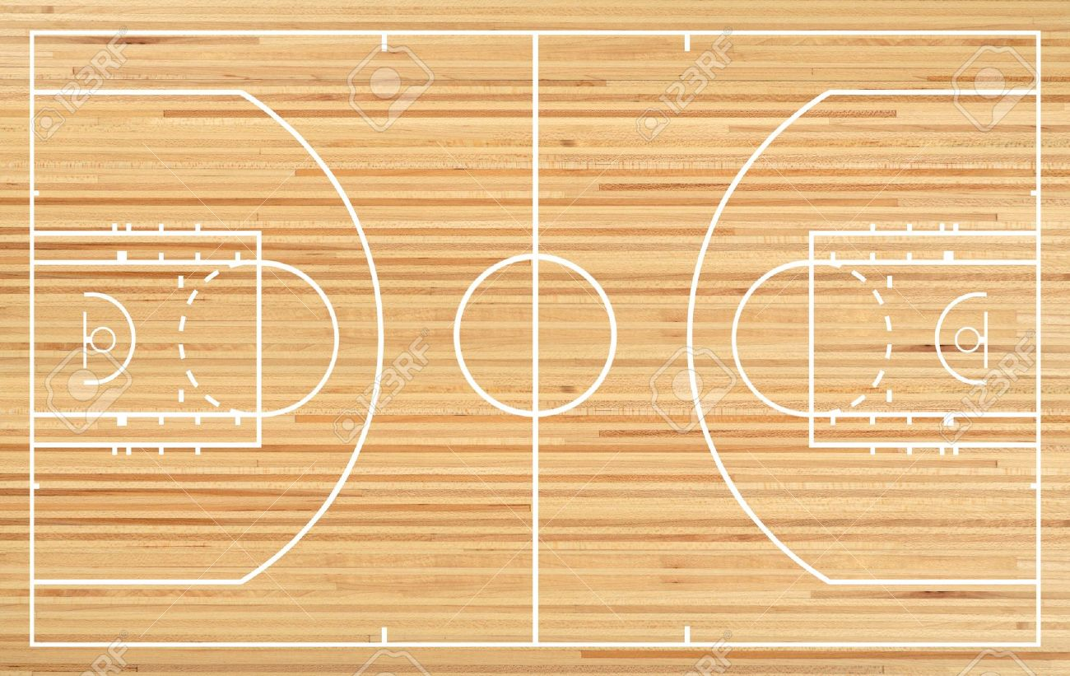

**Comps**